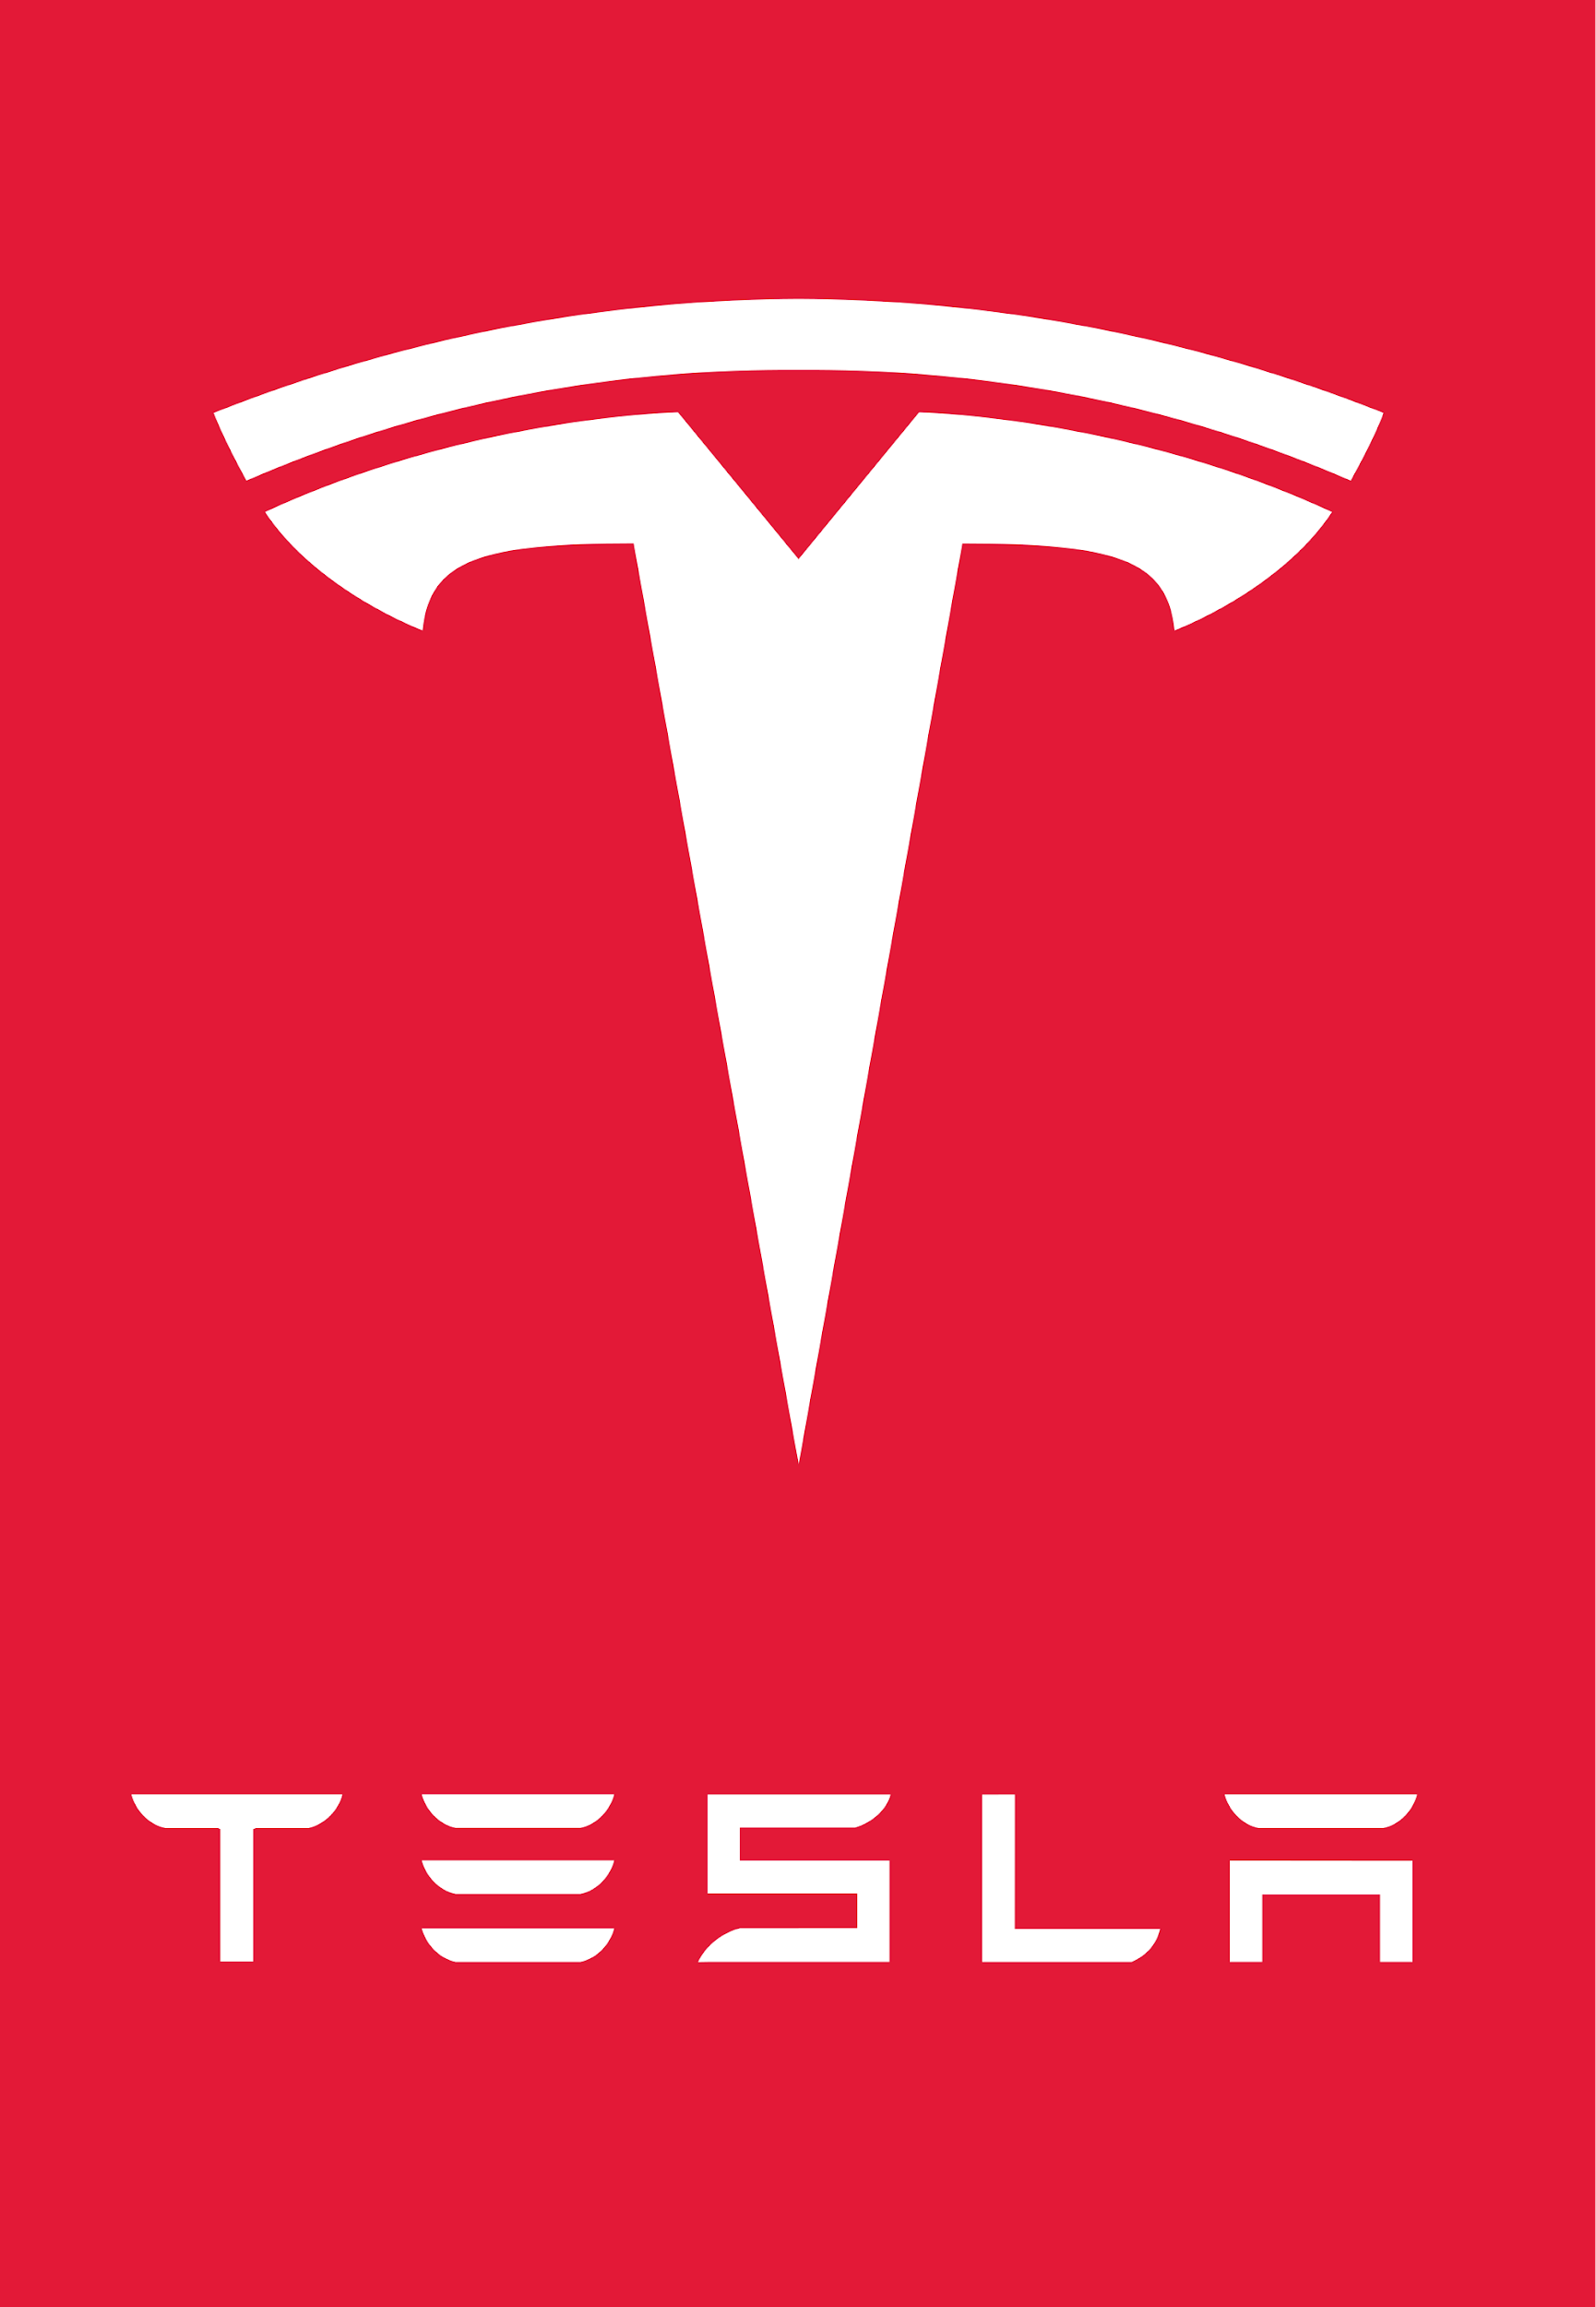

Tesla Inc
Back to The Future Auto Show 2018
Toronto, Ontario, Canada
Press Kit
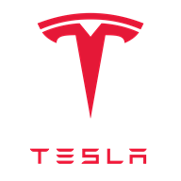

March, 18. 2018

Dear Media Representatives,

Enclosed you will find a press kit featuring an event agenda for the Back to The Future Automotive Show, a Press Release of the event, fact sheets and photographs showcasing Tesla Products (specifically the Model 3), Tesla company’s history and information, information about our sponsors and biographies about our featured Special Guests.

The Tesla Back to The Future Automotive Show is once in a lifetime opportunity to hear talks from Elon Musk and Michael J. Fox, interact and enjoy the new features of Tesla Model 3 and immerse yourself in the excitement and nostalgia in technology and the future.

For further information regarding the event or any of brands or sponsors please contact:

John Smith, Tesla Inc 590-0987-8876

William Jones, Michael J Fox Foundation 590-0987-1294

Thank you for your continued interest and support in technology and automotive advancement.

Sincerely,

The Media Team

For Release June, 01. 2018

Attention: Norris McDonald Wheels Editor Toronto Star, Shane Dingman Technology Section Editor The Globe and Mail.

Back to The Future Automotive Show

“If my calculations are correct, when this baby hits 88 miles per hour... you're gonna see some serious shit.”
- Dr. Emmett Brown

Introducing The TESLA Model 3

March 5, 2018 @ 8:30 AM, Mississauga, ON On July 7, 2018 The Tesla Inc, Automotive Company will be hosting the first ever Tesla Back to The Future Auto Show at the BMO Institute for Learning in Toronto, Ontario. This one day event will feature the Model 3, Tesla’s newest automobile. Creating the Back to The Future theme, Tesla employees will be dressed in Dr. Emmett Brown inspired attire and event attendees will receive a Marty Mcfly style Tesla jacket as they learn about and test drive the Model 3.

The model 3 is will be the fourth Tesla vehicle to enter the Canadian automotive market. The Model 3 is a smaller, simpler, more affordable electric car than Tesla’s previous models such as the Model S. Although it is our newest vehicle, Model 3 is not “Version 3” or the most advanced Tesla. Like Model S, it is designed to be the safest car in its class. You can reserve a model 3 today while deliveries will begin in late 2018.

- Page 1 of 3 -

The day will feature two talks before attendees get to test drive a new Model 3. Elon Musk the celebrity entrepreneur and founder of Tesla will present first followed by Michael J Fox, famous celebrity actor of Back to The Future and founder of the Michael J Fox Foundation. The Michael J. Fox Foundation will sponsor the event and donations can be made at the end of the day.

“Knowing the troubles many people have with Parkinson’s Disease, I am truly humbled that someone like Elon Musk would incorporate his Branding and Custom Technology for such a terrific and personal cause. I know what my next car is going to be. The future is here with the Model 3! Thank you Elon.” - Michael J. Fox

“Growing up watching Back to the Future was an awe-inspiring and imagination driven experience. It inspired me to want to build and create things that noone has ever created before and I maybe even owe some of my success to Doc and Marty McFly’s antics through Time. Michael J. Fox is one of the best people I have ever had the pleasure of meeting and I am honored to put my brand beside his…” - Elon Musk

For Event Registration Information or any inquiries involving the event Please Contact Your Nearest Tesla Dealership.

TESLA INC.

Tesla’s mission is to accelerate the world’s transition to sustainable energy.
Tesla was founded in 2003 by a group of engineers who wanted to prove that people didn’t need to compromise to drive electric – that electric vehicles can be better, quicker and more fun to drive than gasoline cars. Today, Tesla builds not only all-electric vehicles but also infinitely scalable clean energy generation and storage products. Tesla believes the faster the world stops relying on fossil fuels and moves towards a zero-emission future, the better.

THE MICHAEL J FOX FOUNDATION FOR PARKINSON'S RESEARCH

The Michael J. Fox Foundation is dedicated to finding a cure for Parkinson's disease through an aggressively funded research agenda and to ensuring the development of improved therapies for those living with Parkinson's today.

- Page 2 of 3 -

BMO INSTITUTE FOR LEARNING

BMO Institute for Learning (IFL) is the perfect place to meet, eat, play, and stay. Our unique space has been paired with memorable food offerings, social activities, and best-in-class service. When you host your trade show, meeting or conference with us, your attendees will connect and learn in ways you never imagined

- XXX -

For Event Registration Information or to arrange an interview with either Elon Musk or Michael J Fox, Please Contact

John Smith, Tesla Inc

William Jones, Michael J Fox Foundation

Event Schedule

Time | Activity
8:00 AM | Breakfast - Non Stay Guest Pick Up
9:00 AM | Non Stay Guests Arrive/ Introduction Presentation - Welcome
10:00 AM | Elon Musk Talk
11:00 AM | Michael J Fox Talk
12:00 AM | Lunch
1:00 AM | Test Drives
2:00 AM | Test Drives
3:00 AM | Sign Ups and Donations
4:00 AM | Closing Presentation/Thank You

Elon Musk Biography
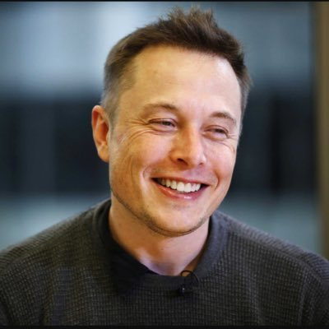

Elon Musk is a South African-born Canadian American business magnate, investor,and engineer. Born in Pretoria, South Africa Musk taught himself computer programming at the age of 12. He moved to Canada when he was 17 to attend Queen's University after two years he transferred to the University of Pennsylvania where he received an economics degree from the Wharton School and a degree in physics from the College of Arts and Sciences. He began a PhD in applied physics and material sciences at Stanford University in 1995 but dropped out after two days to pursue an entrepreneurial career.

He subsequently co-founded Zip2, a web software company, then founded X.com, an online payment company. It merged with Confinity in 2000 and became PayPal, which was then bought by eBay.

Today Musk is the founder, CEO, and lead designer of SpaceX, co-founder, CEO, and product architect of Tesla, Inc.; and co-founder and CEO of Neuralink.

As of February 2018, he has a net worth of $20.8 billion and is listed by Forbes as the 53rd richest person in the world.

Michael J. Fox Biography

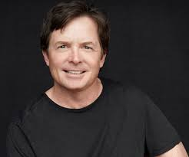

Michael J. Fox, is a Canadian-American actor, author, comedian, producer, and activist. Fox gained stardom when he starred in the Back to the Future trilogy, where he portrayed Marty McFly. Other notable roles during his acting career have included Mike Flaherty on the ABC sitcom Spin City (1996–2000) and his portrayal of Alex P. Keaton on the American sitcom Family Ties. Throughout his career, he has won five Emmys, four Golden Globes, and two Screen Actors Guild Awards.

Fox was diagnosed with Parkinson's disease in 1991, at age 29, and disclosed his condition to the public in 1998. He has since become an advocate for research toward finding a cure. Fox created the Michael J Fox Foundation in 2000 and the organization has since become the largest nonprofit funder of Parkinson's disease research in the world, investing more than $650 million in research to date.

Tesla Model 3
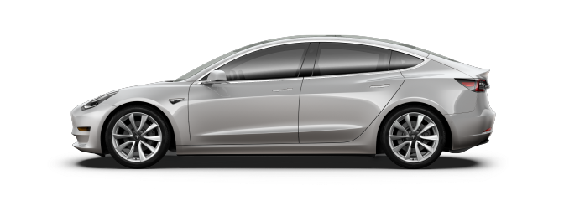

Delivery Timing

12 - 18 months
  - As we ramp production, deliveries for Model 3 reservations placed today will begin in late 2018.
Performance

5.1 - 5.6 sec 0-60 mph

Range

220 - 310 Miles Range

Supercharging

Pay Per Use Supercharging

Passenger

5 Adults

Cargo

15 cu ft
  - Front & Rear Trunk Cargo Volume with Manual Trunk
Displays
- 1 Digital Display (15" Center Touchscreen)
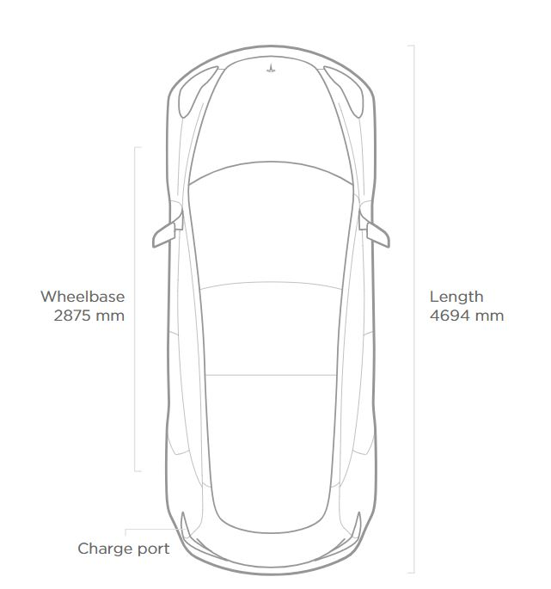
Model 3 Specs

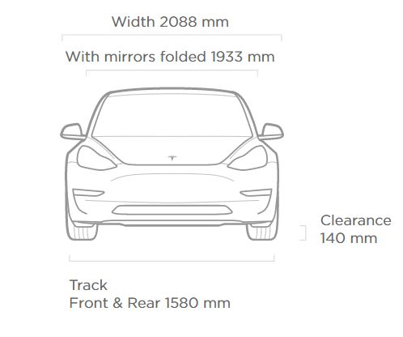

Safety
- Automatic emergency braking and collision avoidance
- Eight airbags
- Electronic stability and traction control

Convenience
- 15″ touchscreen with onboard maps & navigation
- Wi-Fi and LTE internet connectivity
- Keyless entry and remote climate control with app
- Voice activated controls
- 60/40 split folding rear seats

Standard Interior
- 15” touchscreen display
- Dual zone climate control system
- FM/Internet streaming radio
- Textile seating
- Center console with open storage and two USB ports

Premium Upgrades
- Premium heated seating and cabin materials throughout, including open pore wood décor and two rear USBs
- 12-way, power adjustable front seats, steering column and side mirrors, with custom driver profiles
- Premium audio system with more power, tweeters, surround speakers and subwoofer
- Tinted glass roof with ultraviolet and infrared protection
- Auto dimming, power folding, heated side mirrors
- LED fog lamps
- Center console with covered storage and docking for two smartphones

Product Images

